Name ______________________ Photoshop Intro Part 2
How to open Photoshop:

How to find your photo and open it:

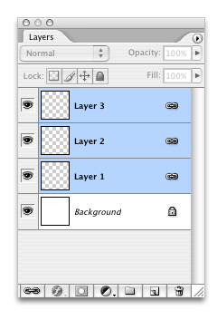  LAYERS  Where are they:  What should I do with them: | Painting Tools:  What is this 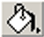 and where is it:  What is this 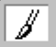and how do I change the size and softness:
Adjustment Layers:  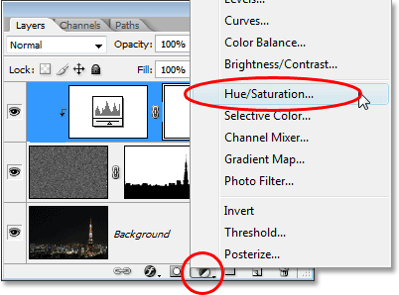  Where are they:  What should I do with them? | Blending Modes:  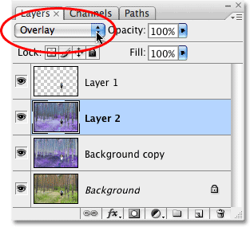  Where are they:  What should I do with them:
Layer Masks:  To add a layer mask:  Painting with Black =  Painting with White= | Filters:  Where are they:  Make sure you duplicate original layer:  What should I do with them:

