Name ______________________ Intro to Photoshop

How to open Photoshop:  HOW TO TAKE AN IMAGE OFF THE INTERNET AND PUT IT IN PHOTOSHOP: | ZOOM    How to zoom in:  How to zoom out:  Keyboard help:
SELECTING TOOLS  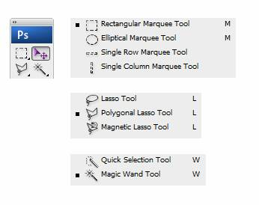  Why select:  How select:  How to add to selection:  How to take away from selection:  Magic wand inverse trick: | COPY AND PASTE  KEYBOARD:  MENU BAR:
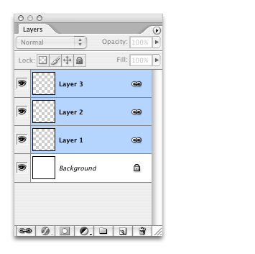
LAYERS

Make a new layer:

Move layers:

Rename layers:

TRANSFORM TOOLS  What they do:  KEYBOARD:  MENU BAR: | HISTORY  What it does:  Where it is:

